ER Diagram

of

**KRISHAK**

Submitted as a part of course curriculum for

**Bachelor of Technology**

in

**Computer Science**



**Submitted by**

Kushagra Singh (2100290120099)

Nancy Srivastava (2100290120109)

Tushtee Singh (2100290120176)

Surabhi Agnihotri (2100290120169)

Under the Supervision of

**Dr. Harsh Khatter**

Assistant Professor

CS Department

**KIET Group of Institutions, Ghaziabad Department of Computer Science**

**Dr. A.P.J Abdul Kalam Technical University**

**2024-2025**

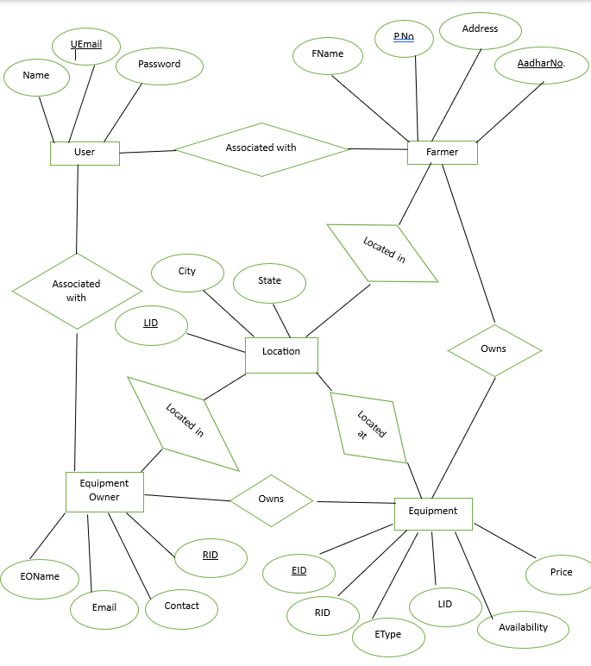**ER DIAGRAM**